**ORXe-Counter**

### Document Properties

| Item | Details |
| --- | --- |
| Document | Technical Specification Document |
| Application | Orxe-counter (version: 0.0.2) |
| Author | Ruchira Rokade |
| Creation Date | 20/9/2020 |
| Last Updated | 21/9/2020 |
| Status | Completed |

Contents

Document Properties 1

1. Component Overview 3

1.1 Objective 3

1.2 Diagram 3

1.3 Use Cases 3

1.4 Risks 4

1.5 Out of Scope 4

2. Technical Specifications 4

2.1 NPM details 6

2.2 NPM repo 6

3.Unit Testing 6

4. Assumptions 7

5. Concerns and Issues 7

1. Component Overview

This document provides an overview of the counter component. The component can be used to take a numerical input from the user, and the user has the functionality to increment and decrement the value.

1.1 Objective

The counter element is used to increment/decrement a numerical value.

It consists of three parts:

* **Increment button** – It is responsible for incrementing the numerical value of count
* **Decrement button** – It is responsible for decrementing the numerical value of count.
* **Count** – It is the value which can be incremented/decremented
* **Minimum value** – The Count cannot be decremented beyond the minimum value.
* **Maximum value** – The count cannot be incremented beyond the maximum value.

1.2 Diagram

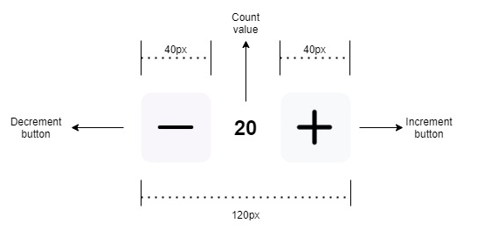

1.3 Use Cases

This document focuses on following use cases of the counter component:

* **Normal counter**: Both the buttons; increment and decrement are enabled

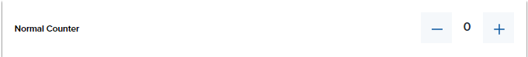

* **Increment disabled**: The increment button is disabled, the user can only decrement the value

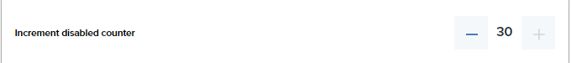

* **Decrement disabled**: The decrement button is disabled, the user can only increment the value

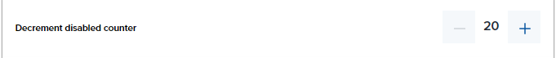

* **Increment button disabled when the count reaches maximum value**: When the count value reaches the maximum specified value, the increment button is disabled.

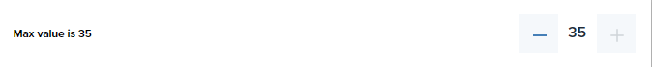

* **Decrement button disabled when the count reaches minimum value**: When the count reaches the minimum specified value, the decrement button is disabled.

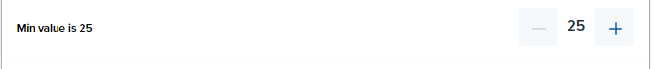

1.4 Risks

NA

1.5 Out of Scope

Defined certain styles for alignment and positioning for creating the base component.

2. Technical Specifications

The counter component can take in up to following properties:

* **Count value** **(count)**– The count value can be initialized and from there the user can choose to increment/decrement the value. In case no value is provided, the count value accounts to 0 by default.

Usage: <orxe-counter count=”10”></orxe-counter>

* **Disabled increment button (DisableInc)** – This property specifies if the user wants to disable the increment button so that the count value cannot be incremented any more. If no value is passed, the disableInc value is false by default.

Usage: <orxe-counter count="20" disableInc="true"></orxe-counter>

* **Disable decrement button (DisableDec)** – This property specifies if the user wants to disable the decrement button so that the count value cannot be decremented any more. If no value is passed, the disableDec value is false by default.

Usage: <orxe-counter count="20" disableDec="true"></orxe-counter>

* **Maximum value** **(maxValue)**– The increment button will be disabled when the count reaches the maximum value.

Usage: <orxe-counter count="10" maxValue="9"></orxe-counter>

* **Minimum value** **(minValue)** – The decrement button will be disabled when the count reaches the minimum value.

Usage: <orxe-counter count="10" minValue="5"></orxe-counter>

The component has below technical properties:

|  |  |
| --- | --- |
| **Property** | **Value** |
| Total width | 120px |
| Total height | 40px |
| Height of button container | 40px |
| Width of button container | 40px |
| Button height | 24px |
| Button width | 24px |
| Button Container background | #F8F5FB |
| Label color | #242C38 |
| Icon used | Orxe-icon(ic-add, ic-remove) – 24px X 24px |
| Font family of text (count value) | Proxima Nova |
| Font size | 1.6rem |
| Line height | 1.5rem |
| Letter spacing | 0 |
| Font weight | 600 (semi bold) |

2.1 NPM details

Following packages are installed for project:

"@orxe-components/button": "^1.0.31",

 "@orxe-components/icon": "^1.0.14",

 "@orxe-components/icons": "^1.0.9"

Orxe/cli version – v2.0.20

Following command creating and running the component:

* **Installing** orxe/cli - npm install -g @orxe3/cli
* **Create a new component workspace** - orxe new component-workspace Assignment2-orxe-cli
* **Create a component** – orxe g c counter
* **Serving the component** – orxe serve
* **Testing the component** – orxe test –coverage

Following are the steps to **use the orxe-counter component in another component**

* Go to the component workspace and perform **npm install @Assignment-2-orxe-cli/counter@0.0.2**
* **Use the compone**nt as mentioned in the above section
* Run: **orxe serve**

2.2 NPM repo

The component is published at: https://packages.common.cnxloyalty.com/service/rest/repository/browse/npm-stage-hosted/

3.Unit Testing

The following Unit test cases are written for the counter component:

1. should exist

2. default count should be 0

3. default disableInc should be false

4. default disableDec should be false

5. setting count property

6. incrementing count property

7. decrementing count property

8. decrementing count property when count = 0

9. disabled inc button, click should be falsy

10. disabled dec button, click should be falsy

11. Disable inc button when count = maxValue

12. Disable dec button when count = minValue

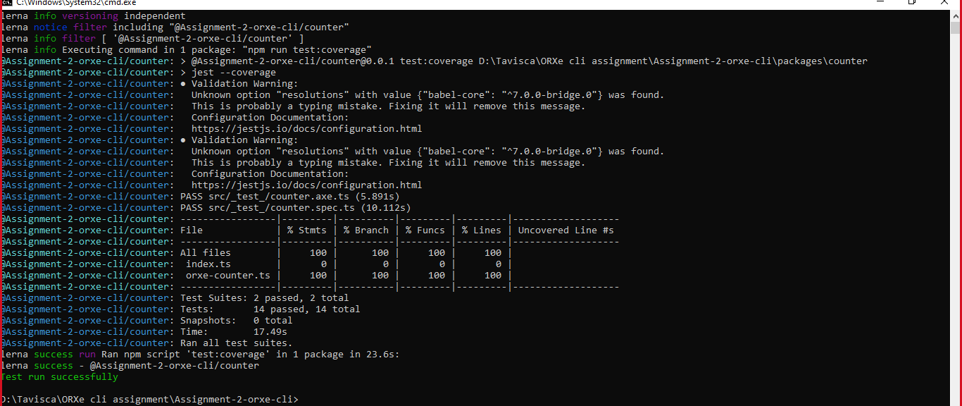

4. Assumptions

This component is developed based on the design guidelines provided on the confluence page.

https://tavisca.atlassian.net/wiki/spaces/ORXE3/pages/780272505/Counter+0.3

5. Concerns and Issues

Due to the npm registry being different, for orxe-icon, the icons; **ic-add** and **ic-remove** is not rendered on the button for increment and decrement respectively.

Instead of icon, the “+” and “–“ signs are rendered.